EMI Filters for PWM-Driven Motors Prevent Bearing Damage and Reduce EMI in Equipment
Santa Cruz, CA, August 14, 2019
OnFILTER' receives U.S. Patent 10,263,591 for its new SF series dV/dt EMI filters for servo motors and variable frequency drives (VFD) that block damaging high-frequency currents from destroying motor's bearings, prolonging life of the motors, lowering maintenance cost, and reducing EMI in equipment.
OnFILTER’s SF series dV/dt EMI filters for PWM-driven motors reduce EMI in equipment and protect bearings without any mechanical attachments or need of maintenance.
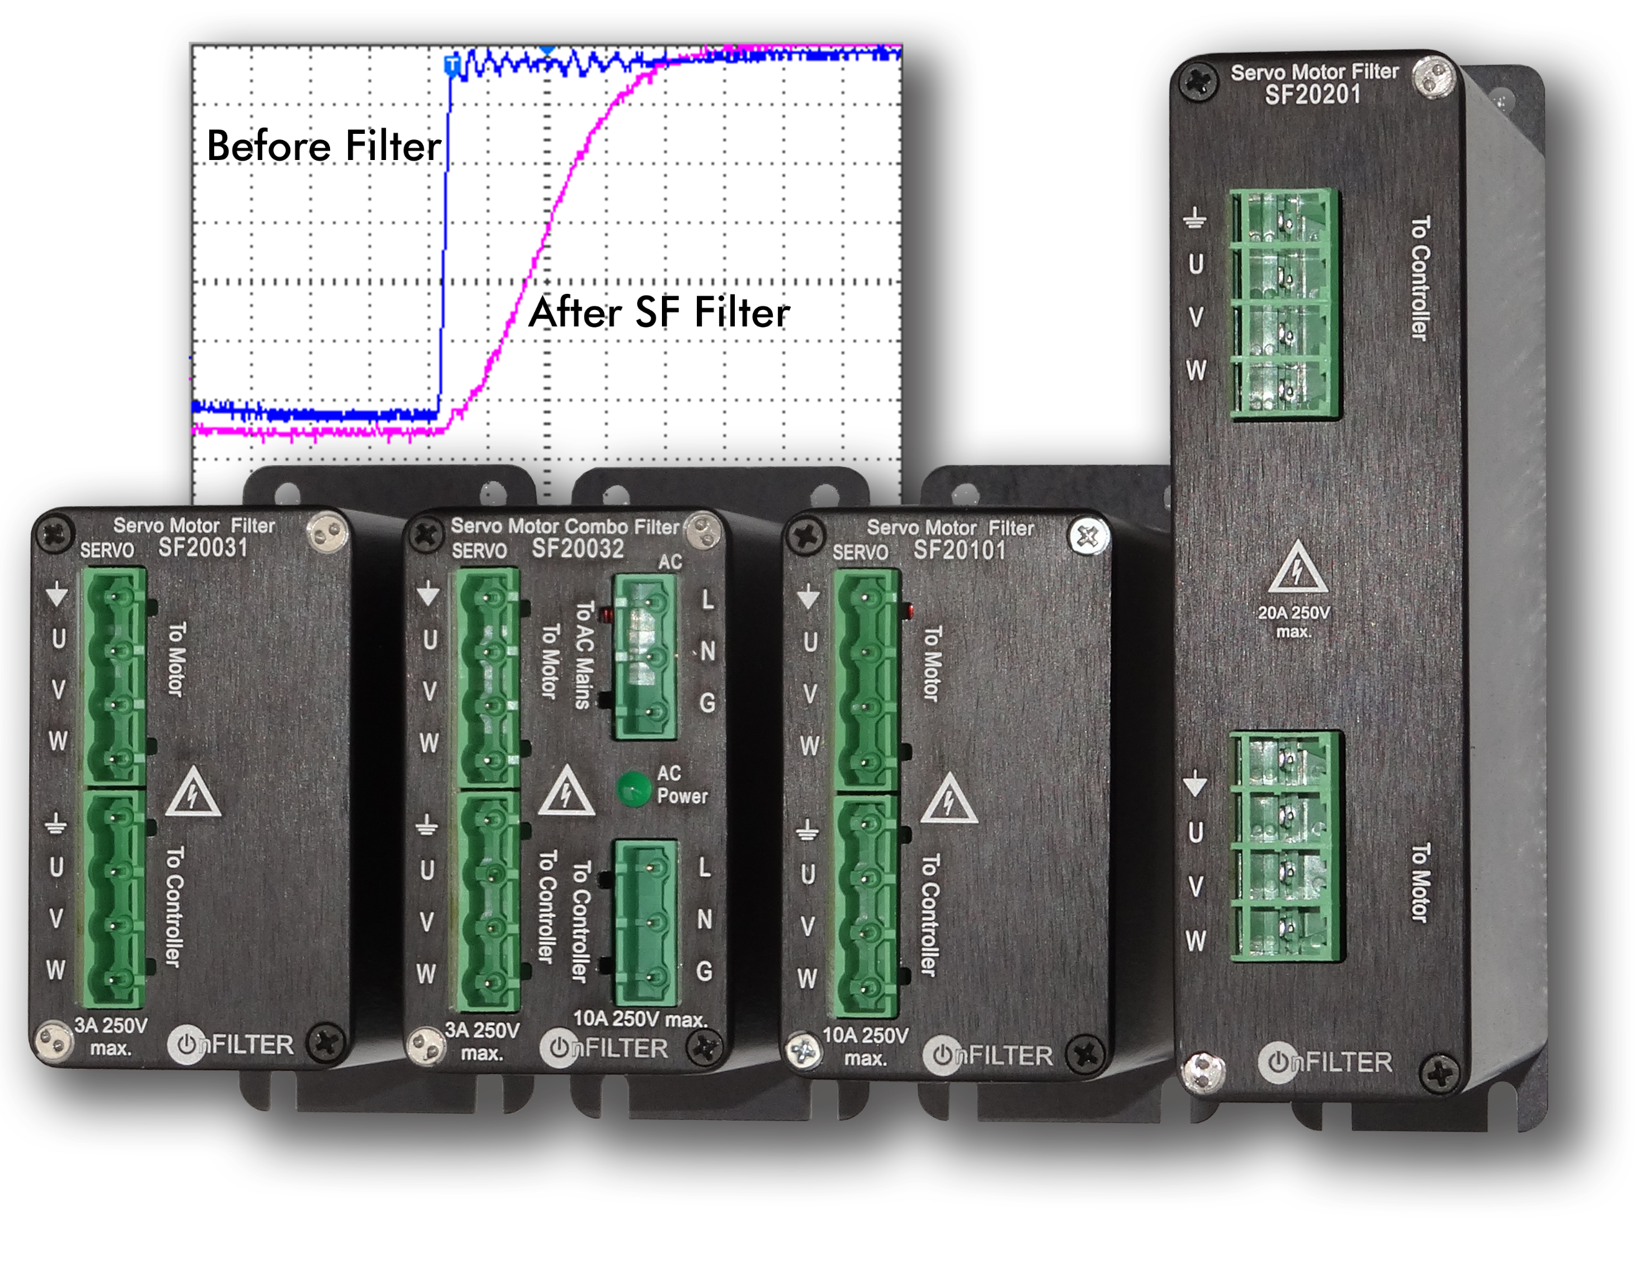OnFILTER' SF Series Filters for Servo Motors and VFD
Link to full-size image
SF series filters help to comply with IEC 60034-17/-25 by “smoothing” sharp edges of drive pulses and applying other patented technology to block ground current through the motor's bearing. This greatly reduces bearing damage prolonging life of motors and reducing maintenance cost.
Easy-to-install patented SF series filters do not require any mechanical modifications to the motor. They are small and unobtrusive providing cost-effective maintenance-free solution to the problem of bearing damage plaguing motion control industry. These filters significantly reduce EMI levels in equipment enabling its error-free operation and decreased occurrences of disrupting "No Fault Found" problems.
Unique combo filter SF20032 combines both AC and motor EMI filtering in one small package providing a complete solution to bearing damage and AC noise issues in one small package.
OnFILTER' President and founder Vladimir Kraz says: "In a highly automated manufacturing process there is little room for dealing with preventable equipment problems and associated loss of productivity. Servo motor and VFD EMI filters are integral part of uninterrupted error-free operation."
SF series filters are rated 3A to 20A up to 250V. The filters carry ETL and CE approvals and are RoHS compliant. All OnFILTER products are manufactured in the U.S. Information on these filters can be found at https://www.onfilter.com/servo-vfd-motor-filters
Contact Information: info@onfilter.com Tel. +1-831-824-4052 www.onfilter.com
About the company: OnFILTER, Inc. (Santa Cruz, CA, USA) is a manufacturer of innovating solutions for EMI management in real-life applications. Its products include filters for power lines and ground, servo motors and VFD, data filters, as well as instrumentation for industrial, scientific, medical and other applications. OnFILTER manufactures its products in the USA and sells and provides support worldwide directly and via local distribution. Learn more at www.onfilter.com

